Lab 4

CapSense Design with BLE Connectivity

Joseph Lundgren and Louis Cooper

Manhattan College

28 October 2016

Embedded Systems Design

Introduction

In this lab we created custom profiles implementing an RGB LED controller through the PSoC 4 BLE and a CapSense slider profile. We will use the Cysmart tool and CySmart mobile app to connect to a GATT server to combine CapSense and BLE in a system.

Procedures

First, we were asked to create a BLE profile. We added a BLE component to the Workspace using the PSoC software. Then we renamed the Custom Service to CapSense Slider, setting the UUID length to 16-bits and setting the value to CAB5. Renaming the Custom Characteristic to CapSense Slider Characteristic, we set the UUID length to 16-bits and set the value to CAA2.

Figure 1 shows us adding another Custom Service renaming it to RGB LED Service. We set the UUID lengths to their correct values in the BLE profile allowing us to use the 4 bytes to send the values controlling the color intensity using three for hue and one for intensity.

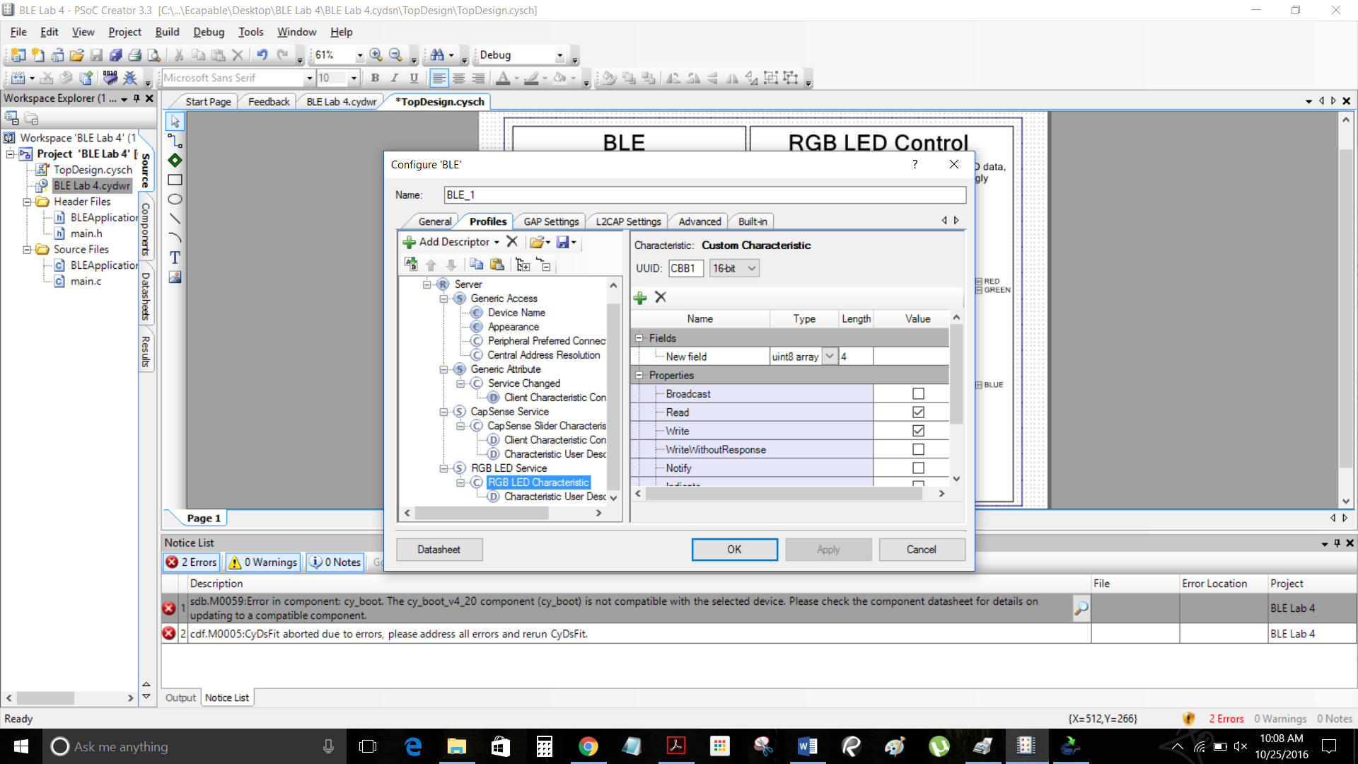

Figure 1

Then we were asked to configure the CapSense Component that was on the Workspace already and part of the template file. Then we configured the pin assignments of the linear slider to pins corresponding to their RGB LED colors. Figure 2 shows a successful build after all of the components have been configured. Figure 3 shows a successful program to the pioneer kit. also demonstrates how to combine CapSense and BLE in a system, by designing a slider application. 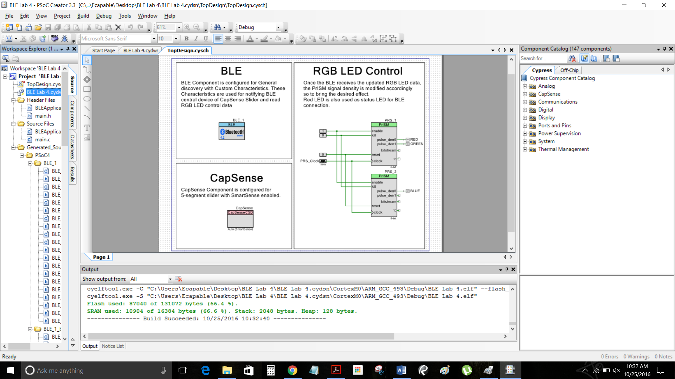

Figure 2

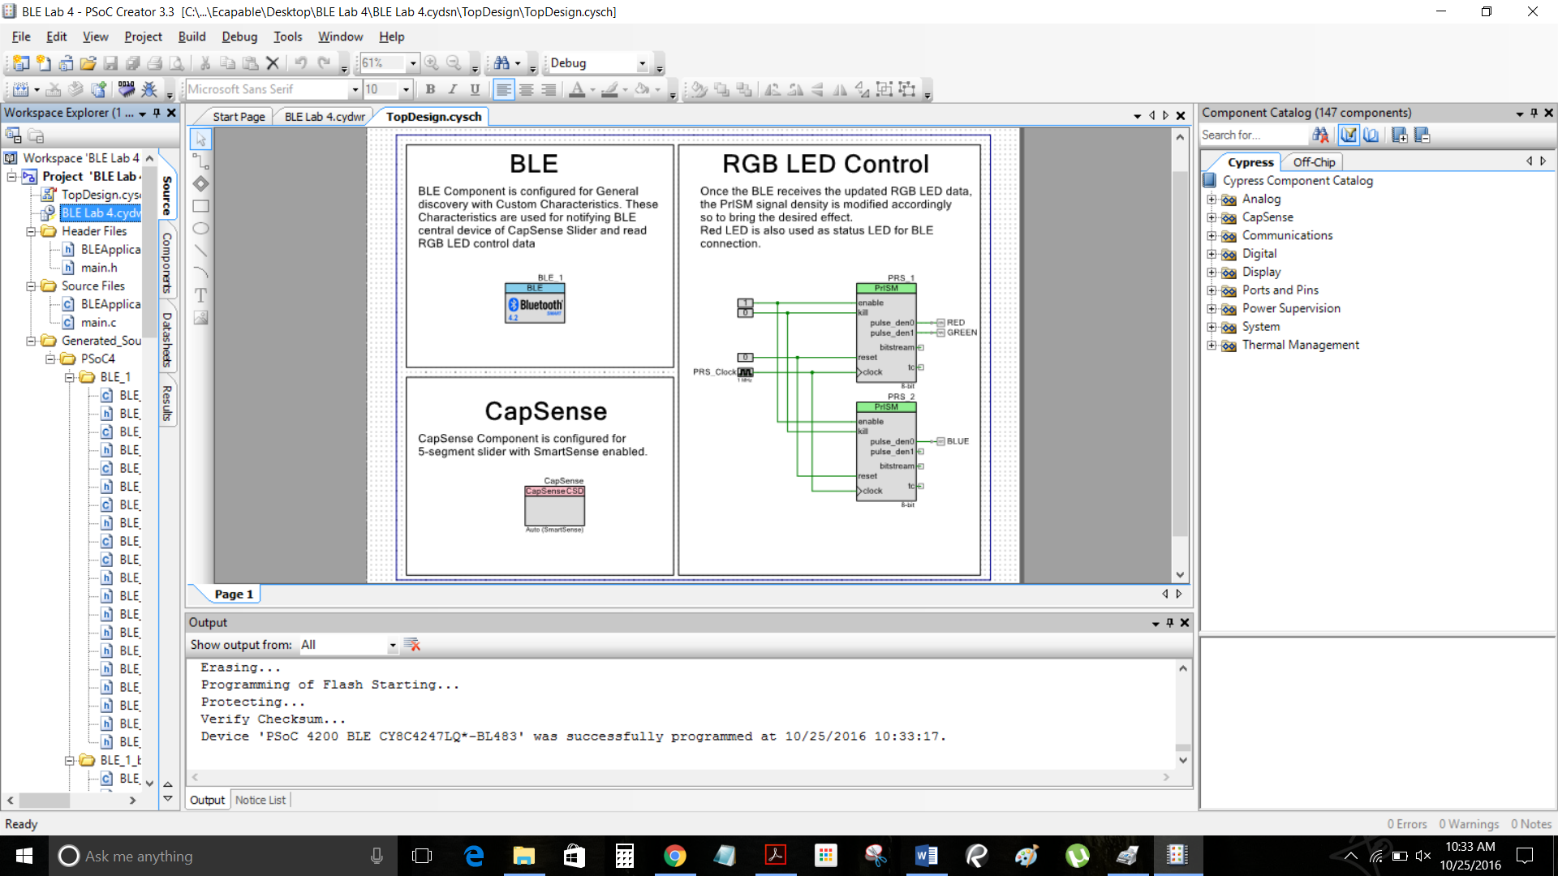

Figure 3

Next we were asked to write a 4 byte value to the RGB LED Characteristic and notice the corresponding color and intensity of the RGB LED on the kit. After writing a value of 00 00 FF FF the LED was blue and at maximum intensity. We then made a red LED at maximum intensity by writing the value of FF 00 00 FF (see Figure 4).

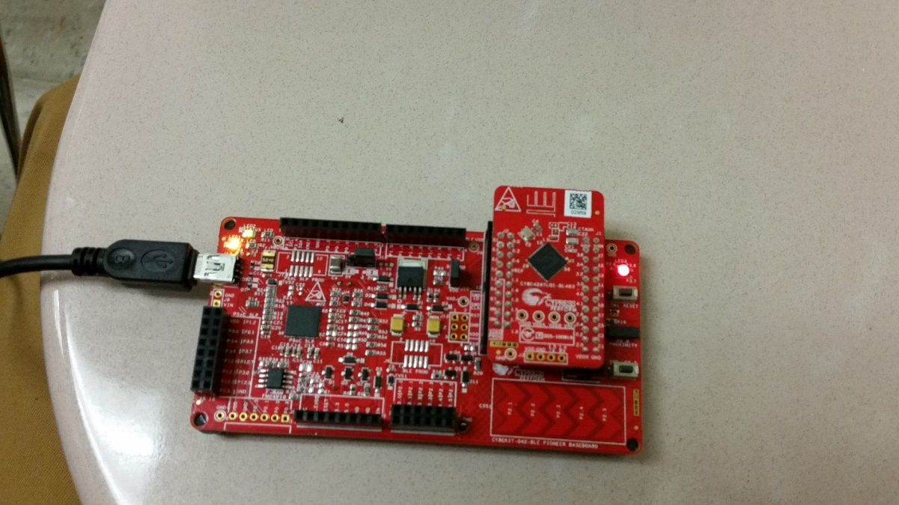

Figure 4

Next we were asked to open the CySmart Mobile App on our phone and connect to GATT Server device. Once we connected, the GATT Server automatically detected the Custom Services for RGB LED and CapSense Slider. Figure 5 shows the color gamut RGB LED Characteristic set 00 B1 FF 80 and corresponding color on the RGB LED on the kit.

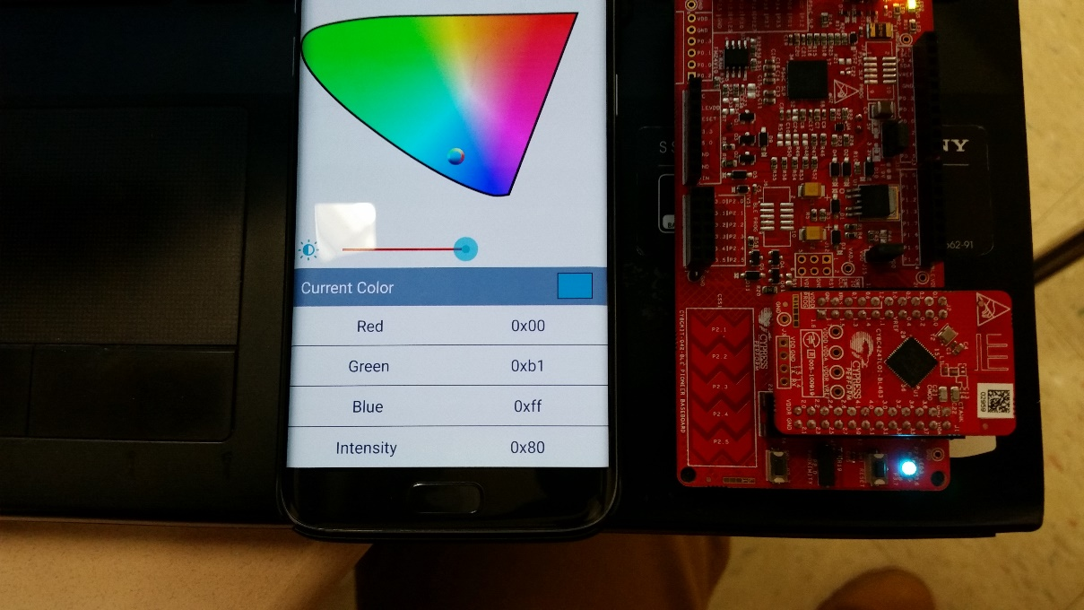

Figure 5

Next, we were asked to locate the CapSense Slider Characteristic and enable notifications for it. Using the CySmart we observed the CapSense Slider Characteristic change as we move our finger over the CapSense slider on the Pioneer kit (See Figure 6). 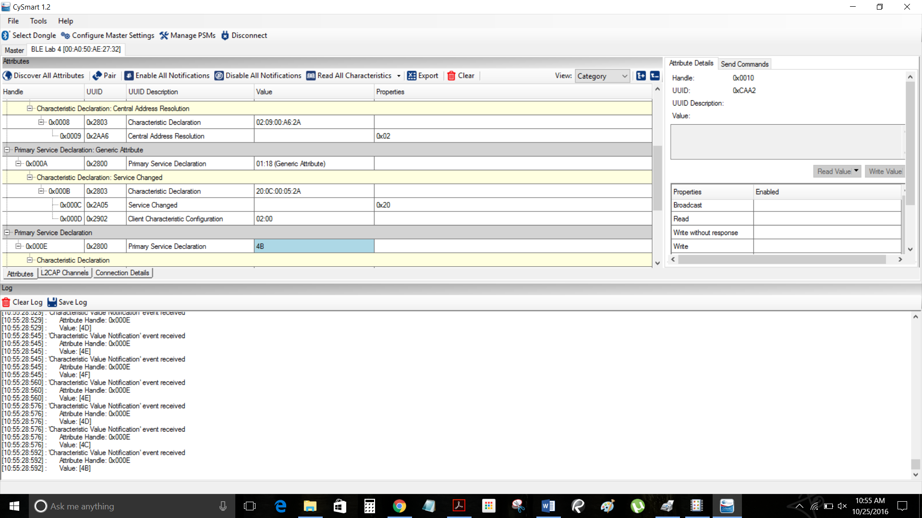

Figure 6

Conclusions

This lab was a way for us to use the Pioneer Kit to program the RGB led by writing a value to the RGB LED Characteristic and create an RGB LED controller through BLE. Using the Android and Desktop CySmart applications we were able to see the results of our configuration. This lab also shows how to combine CapSense and BLE in a system, by designing a slider application. We were also able to see the values in the CySmart application under the attribute corresponding to the CapSense change as we moved our finger across the Pioneer Kit.

Github link:

https://github.com/jlundgren01/Lab4.git